(Thesis hard cover, all in English)

This sample is applied to Natural Science Majors.

Title Font: Times New Roman, Size 16

Student Name e.g.Chen Yanrong (in Chinese Pinyin for Chinese ,Times New Roman, Size 16)
Or Susan Grant (Full-name as registered with the university)
Student No. e.g. 2003050582
Major Food Quality and Safety
Supervisor e.g.Tang Shuze (in Chinese Pinyin,Times New Roman, Size 16)_
Date(dd/mm/yyyy) 22/05/2008

暨 南 大 学
本科生毕业论文

论文题目 中文题目，小三号宋体

学 院_ 国际学院（小三号宋体）
学 系
专 业 食品质量与安全
姓 名 陈彦荣
学 号 2003050349
指导教师 唐书泽
2008年 5月 22日

Statement of Originality

I hereby declare that the thesis presented is the result of research performed by me personally, under guidance from my supervisor. This thesis does not contain any content (other than those cited with references) that has been previously published or written by others, nor does it contain any material previously presented to other educational institutions for degree or certificate purpose to the best of my knowledge. I promise that all facts presented in this thesis are true and creditable.

Signed: _________________ Date：（dd/mm/yyyy)

（Thesis Title )A Sample Thesis for Students of International School

Abstract: A concise abstract should briefly state the main purpose, methods, results, conclusion and significance of the research. An abstract is often presented separate from the article, so it must be able to stand alone. The abstract should be about 150 words with 3-8 key words.
Key Words: One, Two, Three, Four (Notes: All key words must be significance of retrieval)

中文题目(宋体，四号，加粗）

摘 要: 摘要应扼要叙述本论文的主要内容、特点，文字要精炼，是一篇具有独立性和完整性的短文，应包括本论文的主要成果和结论性意见。
摘要中不宜使用公式、图表，不标注引用文献编号，避免将摘要写成目录式的内容介绍，也不要将摘要写成“前言”。（宋体，小四，1.5倍行距）
关键词: 关键词一；关键词二；关键词三 (3~8个关键词，用分号分隔)

Contents
(The table of content should include all parts of the paper, such as introduction, conclusion, acknowledgement, appendix, and references. The page number of these sections should be listed as well.)
1. Introduction 1
2. Methods and principles for accounting standards harmonization 1
2.1 Methods for accounting standards harmonization 5
2.2 Principles for accounting standards harmonization 6
3. Factors that influence accounting standards harmonization 8
3.1 Economic factors 8
3.2 Political factors 9
3.3 Culture factors 10
4. Historical process of accounting standards harmonization 11
4.1 Organizations engaged in accounting standards harmonization 11
4.1.1 International Accounting Standards Committee (IASC) and International Accounting Standards Board (IASB) 11
4.1.2 International Federation of Accountants (IFAC) 12
4.1.3 International Organization of Securities Commissions (IOSCO) 13
4.1.4 United Nations (UN) 13
4.1.5 G4+1 13
4.2 Current evidence on accounting standards harmonization 14
5. Conclusion 20
Acknowledgements 22
Appendix …………………………………………………………………………………….....................23
References 24

1. Introduction
The main text should be typed with Font Times New Roman, Size 12. No indention is needed for the first paragraph. One Tab of indention is used for the rest of paragraphs. Line spacing should be 1.5 times. Also there should be no empty lines between paragraphs.
The introduction should review the theoretical background of the topic and introduce the purpose of the research.

2. Materials and methods
2.1 Materials
Materials, subjects, and equipment (chemicals, experimental animals, apparatus, etc.) used in the experiment should described in this section in which all materials must have clear sources and specification.
Table 2-1 Culture Factor for Accounting Standards
Social culture environment |  | Characteristics of accounting standards
 |  | Setting & implementation | Information  disclosure | Accounting methods
Ⅰ | -Collectivism;  -Strong response;  -Pliable culture | -Emphasize on legislation and administration; | Tend to be inexplicit. | Emphasize on uniformity & conservatism
Ⅱ | -Individualism;  -Weak response;  -Rigid culture | -Emphasize on profession-oriented  -Less government | Tend to be explicit. | Emphasize on flexibility & optimism

2.2 Methods or procedures
The procedures, analytical or test methods and data process carried out should be described in this part.
The SI unit system should be used for all scientific and laboratory data; if, in certain instances, it is necessary to quote other units, these should be added in parentheses. Temperatures should be given in degrees Celsius. The unit 'billion' (109 in America, 1012 in Europe) is ambiguous and should not be used.
Symbols or abbreviations for units should follow the suggestions of the British Standards publication BS 1991. The full stop should not be included in abbreviations, e.g. m (not m.), ppm (not p.p.m.), % and '/' should be used in preference to 'per cent' and 'per'. Where abbreviations are likely to cause ambiguity or may not be readily understood by an international readership, units should be put in full.
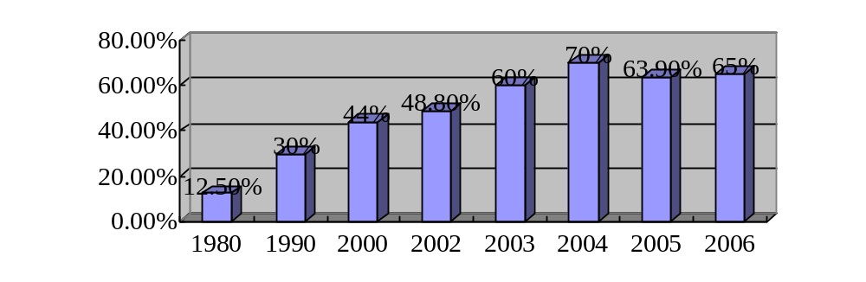
Figure 2-1 Foreign Trade Dependence Degree in China

3. Results
3.1 Result 1…….
Samson (1970 cited in Stone, 1980, pp.44-68) found that……..
The semicolon can be used to separate two sections of a compound sentence that have a similar theme (Turabian, 1996, p.56; Petelin and Durham, 1992, p.169).
‘Some thoughts are best left unsaid’ when emotional issues cloud negotiation (Fisher, Ury and Patton, 1991).
3.2 Result 2…….
Results obtained from experimental study should be reported here following the most important to less important order. All results must be data based with the concrete support by tables and figures.
The format of three lines table is used and all tables and figures should have clear legend or captions.

4. Discussion
This section should summarize the most important findings, point out the indication of the observations, explain the possible mechanism to the results and state how results relate to expectations and to literature cited in the introduction.
In the text refer to the author's name (without initials) and year of publication (e.g. "Steventon, Donald and Gladden (1994) studied the effects..." or "...similar to values reported by others (Anderson et al., 1990)..."). For 2-3 authors all authors are to be listed at first citation. At subsequent citations use first author et al.. When there are more than 3 authors, first author et al. should be used throughout the text.
For Chinese names, please list the surname/family name of the author only (Liao，2005).

5. Conclusion
The conclusion should be a summary of the problems identified and analyzed, the solutions suggested and comments by the author.

Acknowledgements
Here the student can express gratitude to persons or organizations that have provided guidance or funding support and technical assistance in the program study and the process of writing thesis.

Appendix
If the student has some important information to attach to the thesis, but the information is too long in length, or not vital for understanding the thesis, it can be placed in the appendix. The appendix should also have reference for the source of information.

References
In this section, all the citations within the main text of the thesis should be found here. Some examples are listed below. Please note that the references are in alphabetical order. The list of references should be arranged alphabetically by authors' names and should be as full as possible, listing all authors, the full title of articles and journals, publisher and year. The manuscript should be carefully checked to ensure that the spelling of authors' names and dates are exactly the same in the text as in the reference list. The reference format that Elsevier-SDOL (Science Direct Online) journals used is recommended to use:
Author, Initials. (Year). Title of article. Full Title of Journal, Volume number (Issue/Part number), Page numbers.
Ahmed, I. A., & Robinson, R. K. (1999). The ability of date extracts to support the production of aflatoxins. Food Chemistry, 66(3), 307-312.
Appelqvist, I. A. M., Cooke, D., Gidley, M. J., & Lane, S. J. (1993). Thermal properties of polysaccharides at low moisture: 1 - an endothermic melting process and water-carbohydrate interactions. Carbohydrate Polymers, 20, 291-299.
Chapter author(s) surname(s) and initials. (Year of chapter). Title of chapter followed by “In”. Book editor(s)/author(s) initials. surnames, Title of book. (Chapter number or first and last page numbers followed by full-stop). Place of publication: Publisher.
Barber, S. (1972). Milled rice and changes during storage. In D. F. Houston, Rice Chemistry and Technology (pp. 215-263). St. Paul, Minnesota: American Association of Cereal Chemists.
Author, Initials. (Year). Title of topic followed by “In”. title of conference proceedings (Chapter number or first and last page numbers followed by full-stop) Place: Organizer.
Hagawara, N., Tateishi, M., Yamane, T., & Takahashi, T. (1991). Inhibition of azoxymethane-induced colon carcinogenesis in rat by tea polyphenols. In Proceedings of the International Symposium on Tea Science (pp.190-194). Shizuoka: Tea Science Society of Japan.
Hu, X. Z. (1991). The enhancing effect of green tea catechins on cell mediated immunity in mice. Chinese Journal of Microbiological Immunology, 11, 97-99. (In Chinese).
Surname, Initials. (Year). Title of article. Retrieved from: http://www.abcde/fghijk/. (accessed day month year)
United States Environmental Protection Agency. (2000). Risk-Based Concentration Table. Retrieved from:
https://www.epa.gov/risk/regional-screening-levels-rsls-generic-tables-may-2016.
(accessed 19 March 2017)
Surname, Initials. (Year). Title of article. Doctoral/Master’s/Bachelor’s dissertation, University name.
Shen, X. & Yu, S. G. (2008). Analysis and Assessment of Heavy Metal Pollution in Edible Mushrooms from Guangdong. Master’s dissertation, Jiaying University.
Surname, Initials. Title. Patent country. Patent number. The approval time of patent.
Jones, D. A new method for bacterial identification. Chinese patent. 88105607.3[P]. 1989-07-26.

Graduation Thesis Evaluation for Undergraduate Students
Supervisor’s Comments：

Marks：_______/100 Signature：
Date (dd/mm/yyyy):
Evaluator’s Comments:

Marks：_______/100 Signature：
Date (dd/mm/yyyy):
Dean’s Comments:

Marks: _______/100 Signature：
Date (dd/mm/yyyy):

